**Unit Testing using JUnit (Team-06)**

1. **Test the connection.**

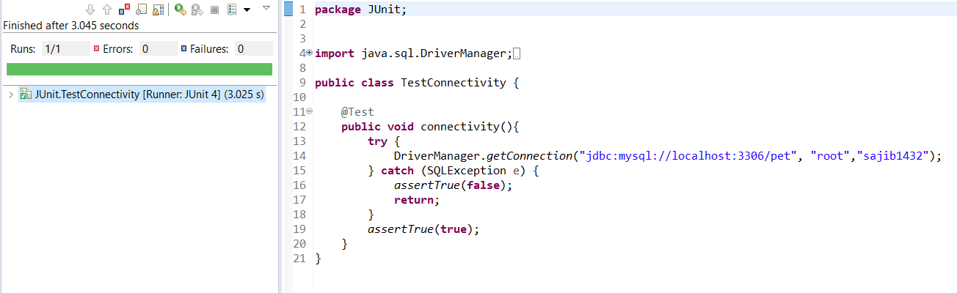

1. **Check different queries (insert, truncate and read data)**

